**AUTOMATION-TESTING**

**Coding contest 2**

**727721EUIT029**

**DHARSITH S**

**PART A**

**CODE:**

package com.selenium.project1.selenium1;

import org.testng.annotations.Test;

import io.github.bonigarcia.wdm.WebDriverManager;

import org.testng.*;

//import org.testng.annotations.BeforeMethod;

import org.openqa.selenium.By;

import org.openqa.selenium.WebDriver;

import org.openqa.selenium.WebElement;

import org.openqa.selenium.chrome.ChromeDriver;

import org.openqa.selenium.chrome.ChromeOptions;

//import org.testng.annotations.AfterMethod;

public class CC {

WebDriver driver;

@Test

public void f() throws InterruptedException{

WebDriverManager.chromedriver().setup();

WebDriver driver;

ChromeOptions co = new ChromeOptions();

co.addArguments("--remote-allow-origins=*");

driver=new ChromeDriver(co);

driver.manage().window().maximize();

driver.get("https://www.yatra.com/hotels");

WebElement flight=driver.findElement(By.xpath("//*[@id=\"booking_engine_flights\"]"));

flight.click();

WebElement trip=driver.findElement(By.xpath("//*[@id=\"BE_flight_form_wrapper\"]/div[1]/div[1]/ul[1]/li[2]/a"));

trip.click();

}

}

**OUTPUT:**

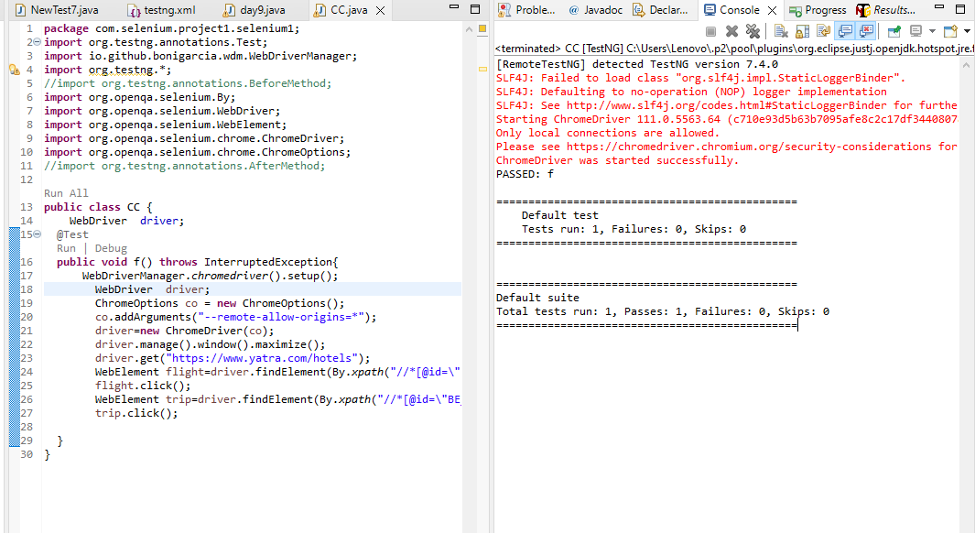

**PART B**

**CODE:**

package com.selenium.project1.selenium1;

import org.openqa.selenium.By;

import org.openqa.selenium.WebDriver;

import org.openqa.selenium.chrome.ChromeDriver;

import org.openqa.selenium.chrome.ChromeOptions;

import org.testng.annotations.Test;

import io.github.bonigarcia.wdm.WebDriverManager;

public class CC {

WebDriver d;

@Test

public void f() throws InterruptedException {

ChromeOptions co=new ChromeOptions();

co.addArguments("--remote-allow-origins=*");

WebDriverManager.chromedriver().setup();

d=new ChromeDriver(co);

d.get("https://www.yatra.com/flights");

d.manage().window().maximize();

Thread.sleep(4000);

d.findElement(By.xpath("//*[@id=\"booking_engine_flights\"]")).click();

Thread.sleep(2000);

d.findElement(By.xpath("//*[@id=\"BE_flight_form_wrapper\"]/div[1]/div[1]/ul[1]/li[2]/a")).click();

Thread.sleep(2000);

d.findElement(By.xpath("//*[@id=\"BE_flight_origin_city\"]")).click();

Thread.sleep(2000);

d.findElement(By.xpath("//*[@id=\"BE_flight_form_wrapper\"]/div[1]/div[2]/ul/li[1]/ul/li[1]/div/div/ul/div/div/div/li[3]")).click();

Thread.sleep(2000);

d.findElement(By.xpath("//*[@id=\"BE_flight_form_wrapper\"]/div[1]/div[2]/ul/li[1]/ul/li[3]/div/div/ul/div/div/div/li[4]")).click();

Thread.sleep(2000);

d.findElement(By.xpath("//*[@id=\"BE_flight_origin_date\"]")).click();

Thread.sleep(2000);

d.findElement(By.xpath("//*[@id=\"20/04/2023\"]")).click();

Thread.sleep(2000);

d.findElement(By.xpath("//*[@id=\"BE_flight_arrival_date\"]")).click();

Thread.sleep(2000);

d.findElement(By.xpath("//*[@id=\"24/04/2023\"]")).click();

Thread.sleep(2000);

d.findElement(By.xpath("//*[@id=\"BE_flight_paxInfoBox\"]/i")).click();

Thread.sleep(2000);

d.findElement(By.xpath("//*[@id=\"BE_flight_passengerBox\"]/div[1]/div[1]/div/div/span[2]")).click();

Thread.sleep(2000);

d.findElement(By.xpath("//*[@id=\"flight_class_select_child\"]/ul/li[3]")).click();

Thread.sleep(2000);

d.findElement(By.xpath("//*[@id=\"BE_flight_form_wrapper\"]/div[3]/div[1]/div[1]/a/i")).click();

Thread.sleep(2000);

d.findElement(By.xpath("//*[@id=\"BE_flight_flsearch_btn\"]")).click();

  }

}

OUTPUT:

